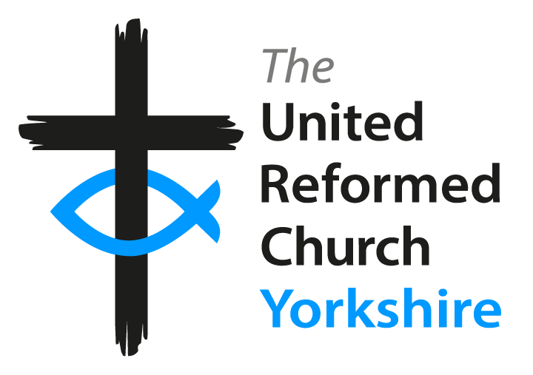

Yorkshire Synod Model Safeguarding Policy
for children, young people & adults at risk
Church Safeguarding Policy
children, young people & adults at risk

Anywhere Church Safeguarding Policy for Children, Young People and Adults at Risk

The purpose of this policy is to ensure procedures are in place and all adults working in or on behalf of Anywhere Church are clear about roles and responsibilities for the protection of children and adults at risk. It is supported by the detailed overarching Safeguarding Policy of the Yorkshire Synod, and the national URC Safeguarding Guidelines.

Everyone working in or for our church shares an objective to help keep children, young people and adults at risk safe by contributing to providing a safe environment for all.

Church commitment – children and young people (under 18years)
Anywhere Church is committed to safeguarding and promoting the welfare of all of its children and young people. It is recognised that some children may be especially vulnerable to abuse. We recognise that children who are abused or neglected may find it difficult to develop a sense of self worth and to view the world in a positive way. Whilst at church based activities, their behaviour may be challenging or withdrawn. We recognise that some children who have experienced abuse may harm others. We will always take a considered and sensitive approach in order that we can support all of our children and young people

We ensure that all appropriate measures are applied in relation to everyone who is involved in working and volunteering with children in church. All adults must be perceived by the children as safe and trustworthy. DBS (Disclosure and Barring Service) checks are made for all adults working with children and young people in church, and all adults are expected to complete training within a year of taking up a paid or voluntary role

All leaders who work with children and at church based activities have undertaken safeguarding training. (Please enter your own church details of groups here and whether there are any professionals in public sector who have had training – they do not need to be named)

Safe practice ensures that children and young people are safe, and that all adults:
- Are responsible for their own actions and behaviour and should avoid any conduct which would lead any reasonable person to question their motivation and intentions
- Work in an open and transparent way
- Discuss and/or take advice from the named Safeguarding Link Person (SLP) over any incident which may give rise to concern. Where the SLP is unavailable the Synod Safeguarding Adviser should be contacted

We are committed to working with parents and carers positively, openly and honestly. We ensure that all parents/carers are treated with respect, dignity and courtesy. We respect parents/carers’ rights to privacy and confidentiality and will not share sensitive information unless we have permission or it is necessary to do so in order to protect a child.
Church commitment – Adults at risk
Anywhere Church recognises that all its members and congregation may be at risk or vulnerable at times in their lives and there needs to be particular care taken for those whose vulnerability is increased by certain situations, by disabilities or by reduction in capacities. It is recognised that this increased vulnerability may be temporary or permanent and may be visible or invisible.

Procedures
It is not the responsibility of the church to investigate welfare concerns or determine the truth of any disclosure or allegation. However, all adults have a duty to recognise concerns and maintain an open mind. Accordingly all concerns regarding the welfare of children will be reported and discussed with the designated person(s) responsible for child protection and the protection of vulnerable adults i.e. the Safeguarding Link Person.
The serious issue of the abuse of children, young people and adults at risk may take the form of physical, emotional, sexual, financial, psychological, online, spiritual or institutional abuse or neglect. We acknowledge the effects these may have on people and their growth and development, including spiritual and religious development. The church accepts its responsibility for ensuring that all people are safe in its care and that their dignity and right to be heard is maintained. There is a responsibility to support, listen to and work for healing with survivors, offenders, communities and those who care about them. The church takes seriously the issues of promoting an individual’s welfare so that each of us can aim to reach our full potential in God’s grace.
The Safeguarding Link Person, working with the Yorkshire synod, commit themselves to respond without delay to any allegation or cause for concern that a child or adult at risk may have been harmed during any church based activity of whatever type. Our church commits itself to challenge the abuse of power of anyone in a position of trust.

Allegations regarding person(s) working or volunteering in or on behalf of church
Where an allegation is made against any person working in or on behalf of the church that he or she has:
- Behaved in a way that has harmed, or may have harmed, a child or adult at risk.
- Possibly committed a criminal offence against or related to a child or adult at risk.
- Has behaved towards a child or children in a way that indicates s/he is unsuitable to work with children.
- Has behaved in an unsuitable manner towards an adult at risk.
Detailed records will be made to include decisions, actions taken, and reasons for these. All records will be securely retained. Whilst we acknowledge such allegations (as all others), may be false, malicious or misplaced, we also acknowledge they may be founded. It is therefore essential that all allegations are investigated properly and in line with agreed procedures.
Initial Action
- The person who has received an allegation or witnessed an event will immediately inform the SLP and make a record. Where the SLP is unavailable the Synod Safeguarding Adviser should be contacted
- In the event that an allegation is made against the SLP, the Yorkshire Synod Safeguarding Adviser will be informed
- The SLP may need to clarify any information regarding the allegation, however no person will be interviewed at this stage
- Consideration will be given throughout to the support children and their parents/carers and to the families of vulnerable adults
- The SLP will inform the Synod Safeguarding Adviser at the Yorkshire Synod and ask for support if necessary

The safeguarding link person for children and young people at Anywhere Church is: Name the person
The safeguarding link person for adults at risk at Anywhere Church is: Name the person

OR

The safeguarding link person for children, young people and adults at risk at Anywhere Church is: Name the person
The deputy safeguarding link person for children, young people and adults at risk at Anywhere Church is:
Name the person

Policy to be reviewed and approved at the Annual Church Meeting/Annually (delete as appropriate and put on the date of the meeting it is approved at)
APPENDIX
PROTECTING CHILDREN

A Child is anyone under the age of 18 (or 25 if there is a special need) and Child Protection seeks to support the child's development in ways which will foster security, confidence and independence. It is regarded as central to the well-being of the individual and is therefore an intrinsic part of all aspects of the church.

Aims
- To encourage all children towards a positive self-image
- To help children view themselves as part of the church community and, by example, to nurture children's abilities to establish and sustain relationships with families, peers, adults and the world outside
- To equip children with appropriate tools to make reasoned, informed choices, judgments and decisions
- To establish and maintain procedures so that all adults in church know how to act if they have concerns or need support regarding a particular child
- To provide a model for open and effective communication between children, parents and other adults working with children

Objectives
- To provide adequate and appropriate staffing to fulfill children’s needs whilst they are in any church organised activity or group, ensuring all adults are clear about their roles and responsibilities
- To create an environment within the church where every child is valued as a member of the community and all members of the community are sensitive and responsive to the needs of others

PROTECTING ADULTS AT RISK

An Adult at Risk is any adult aged 18 or over who, by reason of mental or other disability, age, illness or other situation is permanently or temporarily unable to take care of him or herself, or to protect him or herself from significant harm or exploitation. It is regarded as central to the well-being of the individual and is therefore is an intrinsic part of all aspects of the church.

Aims
- To encourage all adults to treat each other with respect and dignity
- To help adults at risk view themselves as part of the church community and to establish and sustain relationships
- To allow all adults at risk to make reasoned and informed choices, judgments and decisions
- To establish and maintain procedures so that all adults in church know how to act if they have concerns or need support regarding a particular person
- To provide a model for open and effective communication between all adults and children in the congregation and all other church groups

Objectives
- To provide adequate and appropriate staffing to fulfill needs whilst adults at risk are in any church organised activity or group
- To create an environment within the church where every person is valued as a member of the community and all members of the community are sensitive and responsive to the needs of others
It is the responsibility of all adults to identify and report all possible causes for concern or cases of abuse.
INCIDENT RECORDING FORM (to be completed together by the person making an allegation and the safeguarding link person)

Date and time of incident: ………………………….………..

Date on which this report is written……………………………………………

(This should preferably be immediately or no later than up to 48 hours of the incident taking place)

Your name: ……………………………………………………………………………..

Name of Child, Young Person or Adult at risk and date of birth

……………………………………........................................................DOB………………………

Address if known………………………………………………………………………

Recording:
Please ensure you are as accurate and detailed as possible. Use quotes wherever possible – do not interpret what was said using your own words. Do not make suggestions as to what might have been said or done. Listen carefully to what is being said rather than just hearing the account.

Record what you said as well as what the child, young person or adult at risk said.

Include details such where the conversation took place and who else was present, if anyone.

If you have formed an opinion please state it, making it clear that it is your opinion and give reasons for forming that opinion. It would assist, where possible, to also include descriptions of tone of voice, facial expression and body language.

Record of incident(s)

Who have you spoken to about your concerns?

Safeguarding Link Person ……………………………………………….date…………………

Synod Safeguarding Adviser? Name …………………………………………date…………………

Social services? Name……………………………………………date ………………………………

Police? Name…………………………………………………..date……………………………………

NSPCC? Name ………………………………………………date…………………………………….

Parent/carer? Name…………………………………………………date………………………………..

Other? Name……………………………Organisation……………………………..date……………….

Is there any follow up work taking place that you are involved with?

Signed..................................................................... Date.................................

Useful communications

This page needs to contain useful contacts within your locality/local authority e.g.

ADULTS AT RISK

Adult care services in your local authority

Safeguarding adults contact in your local authority

CHILDREN

Duty and assessment contact numbers

For a Child In Need
NSPCC 0808 800 5000
help@nspcc.org.uk
NSPCC text service: 88858

