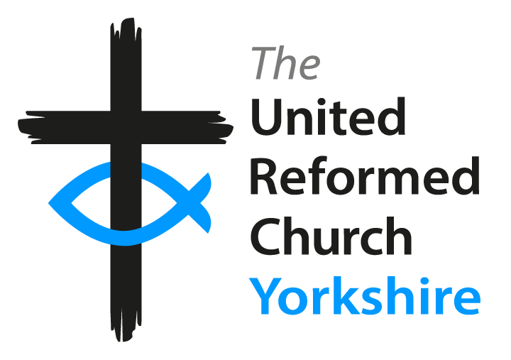

Yorkshire Synod Model Terms of Settlement
guidelines for terms of settlement

Yorkshire Synod Model Terms of Settlement
guidelines for terms of settlement

Preamble

1. When negotiations are taking place to declare permission to seek ministry, part of the pastoral concern of the Synod is to agree with the pastorate the Terms of Settlement which will apply when a new minister is called. Permission to seek ministry will be granted only with the assurance that the proposed Terms of Settlement are in order.

2. These proposed Terms of Settlement are to be agreed by the Synod Pastoral Committee and can then be included with the Pastorate Profile to be shared with a prospective minister.

3. When the pastorate is in discussion with a prospective minister and reaches the point of wanting to issue a call, the Interim Moderator will ensure that the Terms of Settlement based on the draft terms are refined in negotiation with, and signed by the pastorate, minister, and interim moderator, and submitted to the Pastoral Committee for final signature and concurrence of call.

4. Clause 10 of the document is included to enable Synod to alter the nature and composition of a pastorate if the need arises during the period of a ministry. It also enables a pastorate and minister to vary the details of the terms of settlement by mutual agreement and with the consent of the Synod as and when necessary. Synod has decided that it will require all ministers and pastorates to consent to the possible re-scoping of their pastorate during the term of a particular ministry as stated in Clause 11.

Procedures to be followed in drawing up the Terms of Settlement

A. The Synod Pastoral Committee will send one copy of this document to the Church Secretary (or Secretaries in a group or joint pastorate).
B. The pastorate fills it in, with the help of the Interim Moderator(s), and sends the draft as part of the pastorate profile to the Convener of the Synod Pastoral Committee.
The Convener then:
EITHER
- returns the draft to the Church Secretary and notifies the Pastoral Committee that it is satisfied,
OR
2. alters the draft and discusses the proposals with the pastorate, eventually reaching stage 1 above.

C. This draft is used to negotiate with a candidate. When a final form is agreed, it is signed by the minister, the Church Secretary/ies, Church Treasurer/s, the Interim Moderator and returned to the Secretary of the Pastoral Committee for signature on behalf of Synod by the Convener/ Secretary or, in exceptional circumstances, by an Area Representative. One fully signed copy is then returned to the minister, one to the Pastorate and one is held by the Pastoral Committee.

The Pastoral Committee is notified that everything is in order to proceed to granting concurrence.

THE UNITED REFORMED CHURCH - YORKSHIRE SYNOD

Settlement Agreement - [Stipendiary]

This Settlement Agreement is made between

___________________________________________________________________ (the Pastorate)

and the Revd_________________________________________________________ (the Minister)

1. Scope
The pastorate has been declared to be (full time/part-time) scope by the Yorkshire Synod.
It is agreed that the basic pattern for the minister’s time and conduct of worship will be:

……………………………………………………………………………………………………………………………………..
(In a pastorate of more than one church)
It is agreed that the basic pattern for the Minister’s time and conduct of worship will be:

……………………………………………………………………………………………………………………………………..
……………………………………………………………………………………………………………………………………..
2. Stipend The minister will receive the stipend appropriate for a pastorate of this scope from the national Maintenance of the Ministry pay roll office.

3. Housing
The minister will live in the manse provided at ………………………………………………………………………………….………...…..…………………………………………………………………………………………………………………………………………………………
The pastorate will pay the Council Tax, water rates and any other tax[es] on the manse in full; will insure the building and accept responsibility for the maintenance and decoration of the manse. There will be an annual building inspection of the manse.
[Or The minister will live in a house within the pastorate area towards which the pastorate will pay a housing allowance according to the ‘Plan for Partnership’.]

4. Travel
The pastorate will reimburse the minister for using his/her own car in accordance with the recommendations of the URC central committee, and for costs of public transport, upon submission of a written claim (as agreed), and subject to annual review in the light of recommendations from URC Synod and/or finance department. The pastorate will also pay a fixed car allowance of £1,200 per annum.
OR The Pastorate will provide a car for the use of the Minister and will be responsible for all maintenance, servicing, repairs, tax and insurance. The Minister will reimburse the Pastorate at the rate of pence per mile, actual cost a/petrol and oil, or other similar arrangement (viz._________________) , subject to annual review and in the light of any recommendations made by URC Synod and/or finance department.

5. Administration, telephones and Computer
The pastorate will reimburse the minister for all administrative expenses, including stationery and postage, upon submission of a written claim. Telephone(s) will be provided by the pastorate. The minister will be expected to reimburse the pastorate for private telephone calls. A computer will also be provided with access via broadband to the internet. A specification for the computer and details of telephones and broadband will be negotiated and agreed prior to induction. Upgrading the computer will also be negotiated at the appropriate time but normally every four years.
6. Education for Ministry
The pastorate will support the minister in undertaking up to two weeks of Education for Ministry (EM), both EM2 (Report to General Assembly 1998 p.124) and EM3 (Page 126 General Assembly 1998).
The Pastorate will encourage the minister to take Sabbatical leave as recommended in the Plan for Partnership and to attend the annual Synod Summer School, for which the pastorate will pay. The pastorate will also support the ministers in the Ministerial Accompanied Self-Appraisal scheme. Any Sundays involved in these provisions will not be counted as holiday and the pastorate will be responsible for arranging and paying for pulpit supply.
The Pastorate will offer a study allowance of £250 to be offset against the purchase of books, computer software etc.
Pastorates are encouraged to fund attendance of ministers’ spouses at events, if required.

7. Holidays and regular days off
The pastorate will honour recommendations for regular weekly days off, and will follow recommendations regarding holidays in the ‘Plan for Partnership’ (Part III) – viz. five full weeks’ holiday per year (including five Sundays) plus one additional holiday Sunday.

8. Removal costs
The pastorate will accept its share of removal expenses as recommended in the ‘Plan for Partnership’ (Part III).

9. General
The pastorate will honour the United Reformed Church policy to grant maternity/paternity pay and parental/adoption leave and the declaration of Equal Opportunities contained in the URC Employment Practice report accepted by General Assembly 1990.

10. Re-negotiation and Review
The pastorate and minister are willing to re-negotiate these Terms of Settlement during the course of a ministry at the request of the Synod through the Pastoral Committee. Any suggested changes from the pastorate or the minister/s will be subject to the agreement of the Synod.

11. The wider United Reformed Church
The pastorate acknowledges that ministers are ministers of the whole United Reformed Church and have a responsibility to serve the wider church as well as their own local pastorate. Requests for specific pieces of wider service will be discussed between the Elders' Meetings and the minister.

12. Local Ministry and Mission Review
The minister and pastorate will participate in the Local Ministry and Mission Review agreed by Mission Council in December 2008, previously introduced at General Assembly 2006, and implemented through the Yorkshire Synod’s Church Life Review and Ministerial Accompanied Self Appraisal.

13. Generally
Both minister and pastorate will seek to follow the ‘Plan for Partnership’ and the provisions of the ‘Basis for Union.’

14. Review
The terms of this agreement will be reviewed initially after six months and then annually by the pastorate. It may also be reviewed when changes are made to the national and/or Synod guidelines.

Agreement

This agreement was endorsed by the Church Meeting(s)/Elders’ Meeting(s) on

Date:______________________________________________________

Minister Name:______________________________________________________________________

Signature:__________________________________________Date:______________________

Church Secretary(s) Name:______________________________________________________________

Signature:_________________________________________Date:_______________________

Church Treasurer(s) Name:______________________________________________________________

Signature:_________________________________________Date:_______________________

Interim Moderator Name:___________________________________________________________

Signature:_________________________________________Date:_______________________

Pastoral Committee Convener/Secretary Name:____________________________________________

Signature:_________________________________________Date:_______________________

amended March 2019

